

**FACULTY OF APPLIED INFORMATION TECHNOLOGY**

**Field Of Study: Information Technology**

**Specialty: Computer-Science**

BAIMENOVA NAZERKE

No. of student’s record book: 68624

**PROJECT**

**Course: Programming**

**Topic: Web site about me**

**Rzeszow 2023**

**Content table**

1. Main body of 1 web-page

3.1 Design

3.2 Implementation

1.1

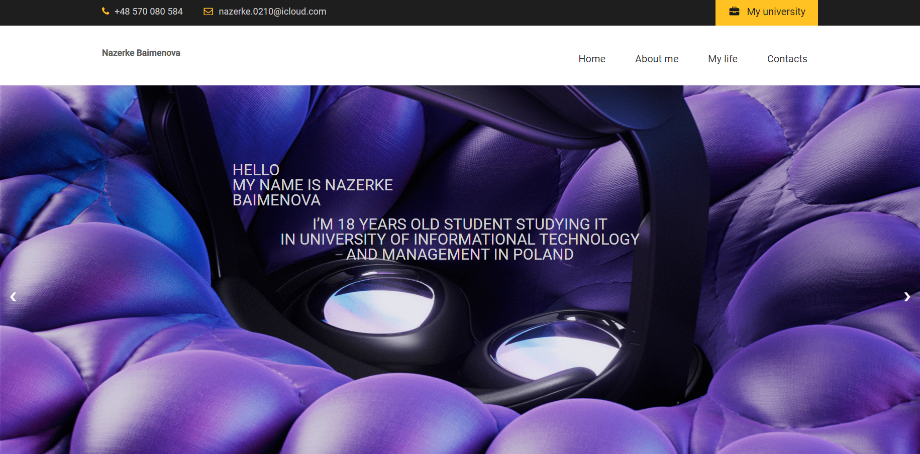

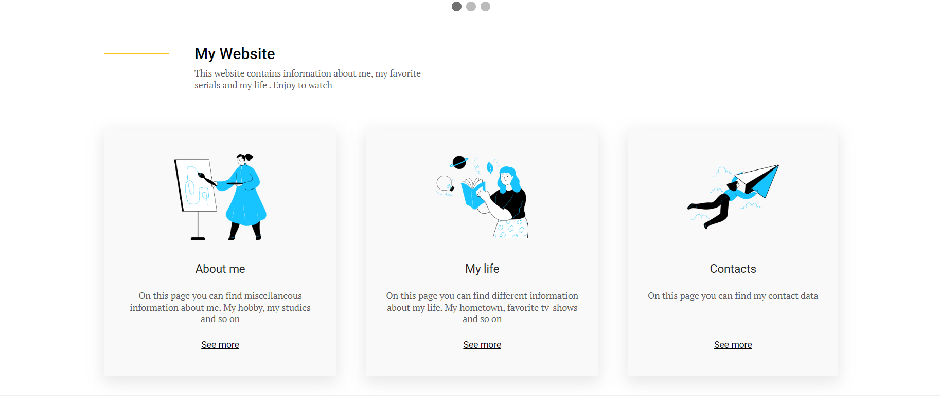

3.2 The first page

The first web page contains general information about me. The header includes elements such as phone number, email address, and a button linking to a university website. The logo displays the text "Nazerke Baimenova," and the navigation menu contains links to "Home," "About me," "My life," and "Contacts" pages. The next code represents a slideshow container with three slides. Each slide is contained within a div with the class "mySlides fade". Inside each slide, there is an image element with a specific source (URL) and dimensions. The images displayed in the slides are sourced from different URLs. Additionally, there is a div with the class "text" that can contain text content.

The slideshow is designed to fade between the slides, creating a visual transition effect.

The CSS code provides styling for the "about" section and its elements. It sets padding, display properties, font styles, background colors, and positioning. The code also applies a box-shadow effect and underline to the item links. These styles create a visually appealing and organized layout for the "about" section.

3.1 The second page

 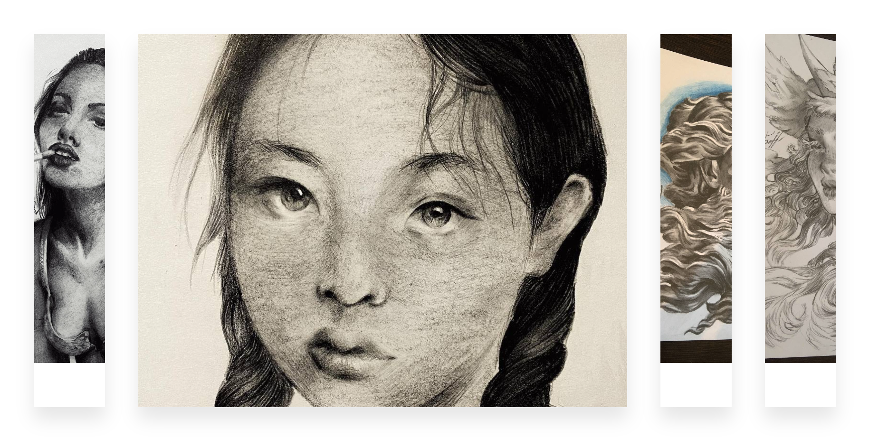

3.2

The first section has the class "myself" and contains a container div. Inside the container, there is an inner div with the class "myself__inner". The second section has the class "dfo" and contains a div with the class "dfo__text". The text inside this div describes my studies in Rzeszow. The third section has the class "uni" and contains three divs with the classes "img", "ima", and "imh". Each div contains an image (my photo and images of university) tag with a specific source file path pointing to images on the local drive.

The HTML code represents a section with the class "hobby" and a container div. Inside the container, there is an inner div with the class "hobby__inner". The "hobby__inner" div contains a title with the class "hobby__title" ("My Hobbies)

Following the section, there is a div with the class "conta" that serves as a container for multiple "box" divs. Each "box" div represents an image gallery item. It contains an image tag with a specific source file path pointing to images on the local drive and an empty span element.

The accompanying CSS code provides styling for the elements. The "hobby__inner" class sets the maximum width of the inner content. The "conta" class is set to display as a flex container, occupying the full width of its parent and with a specific height calculated as 100 viewport height units (vh). It also defines padding, box-sizing, and sets the flex items to be displayed evenly along the main axis.The "box" class represents each image gallery item and defines flex properties, overflow behavior, transition duration, margin, box shadow, and line height. The "box > img" class sets the width and height of the images, object-fit, and transition properties. The "box > span" class styles the empty span element within each box.

3.1 The third page

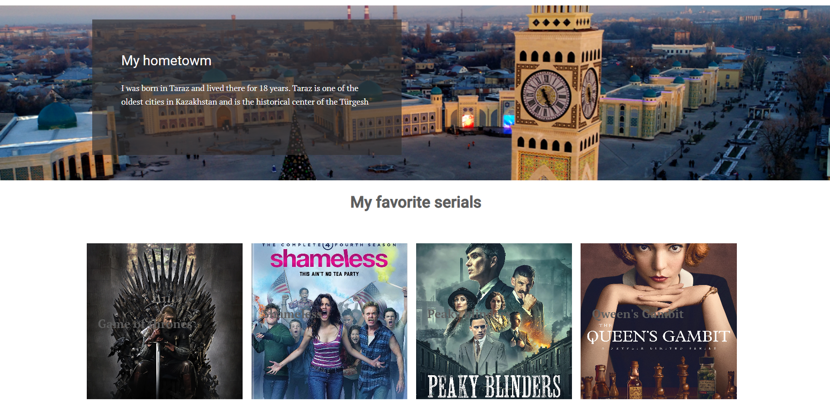

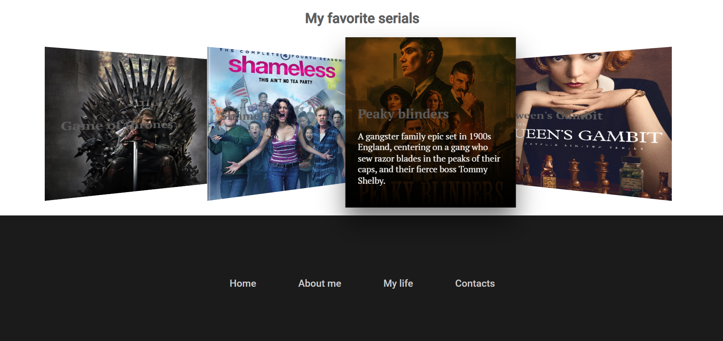

3.2

The given code represents an HTML section with the class "myself". Inside the section, there is a container div with the class "container", and within it, there is an inner div with the class "myself__inner". The accompanying CSS code provides styling for the elements. The ".myself" class sets a background image for the section, with properties to control its size, position, and repetition. It also specifies a minimum height, padding, and margin.

The ".myself__inner" class defines padding and a background color with some transparency. The ".myself__title" and ".myself__text" classes set various styles such as color, font properties, and spacing for the title and text elements. The asterisk selector and the box-sizing property ensure that all elements on the page have the border-box box-sizing model, which includes padding and border in the element's total width and height.

The code represents a webpage section containing information about my favorite TV serials.

The ".cont" class sets the position, width, display, and perspective properties to create a 3D effect for the "box" elements. The ".imgBx" class positions the image within each box and adds a gradient overlay. The ".content" class positions the title and description text at the bottom of each box. The text initially appears hidden and animates into view on hover.

The code also includes a "footer" section with links styled using the ".footer__text", ".index", ".ab", ".life", and ".con" classes. The footer has a background color, padding, and text styling.

Overall, the code creates a visually appealing section with interactive elements for displaying and showcasing favorite TV serials.

3.1 Contact page

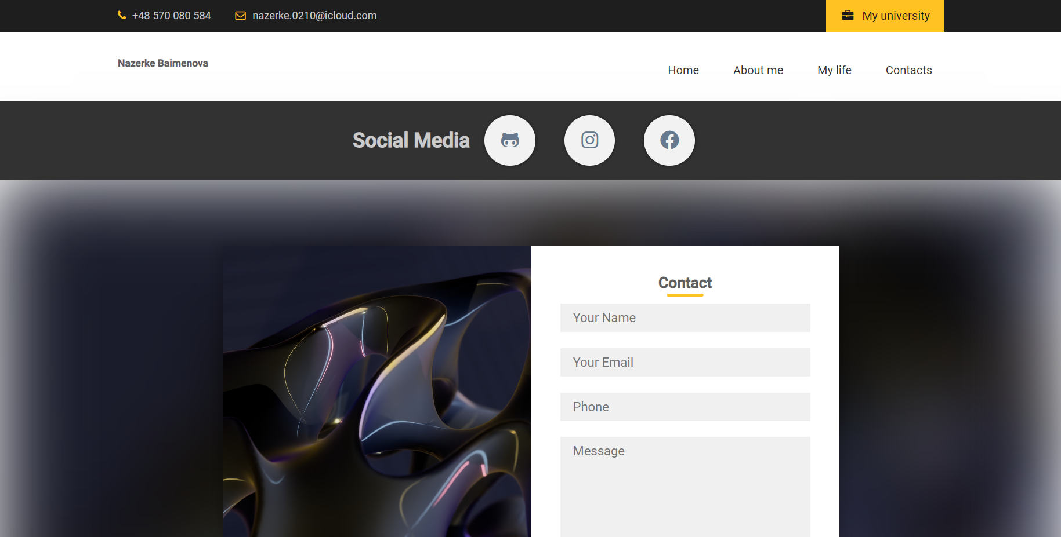





3.2

In the top a section for displaying social media icons with corresponding links.

The CSS code styles the "social" class, flexbox to center-align and center-justify its contents. The `<h1>` heading is styled with centered text alignment. The "social__icon" class styles the anchor elements. They are given a specific width, height, margin, background color, border-radius, and box-shadow, creating circular icon containers. The icons are styled using FontAwesome classes .On hover, the icons and containers undergo various transitions and transformations. The icons change color to "#fff", the containers move up slightly and increase the box-shadow, and an "after" pseudo-element with a circular background color slides up from the bottom.

Each social media platform has a different background color for its "after" pseudo-element, representing the platform's brand color.

Below contact form section and a footer section for a web page.

In the HTML code, there is a `<div>` element with the class "cont" that contains another `<div>` element with the class "cont-box". Inside "cont-box", there are two `<div>` elements, one with the class "left" and the other with the class "right". The "right" div contains a `<h2>` heading, several `<input>` and `<textarea>` elements for capturing contact information, and a `<button>` for submitting the form.

After the "cont" section, there is a separate `<div>` element with the class "footer" that contains another `<div>` element with the class "footer__text". Inside "footer__text", there are four `<a>` anchor elements representing different links.

The CSS code styles these sections and elements. The "cont" class sets the position to relative and applies flexbox to center-align and center-justify its contents. The "cont:after" pseudo-element adds a background image with blur and a negative z-index to create a background effect.

The "cont-box" class styles the contact form container, providing margin, max-width, grid layout, background color, and box shadow.The "field" class styles the text fields and text area, including width, border, background color, padding, and transitions.The "btn" class styles the submit button, including width, padding, background color, color, and transitions.

.